*DOM:*

**(Document Object Manipulation )**How to get changes made changes in browser based webapps , add events on mouse button clicked , hovering whenever happened , hitting enter a change happened.

All this work done through html elements we use with js code features.

To make changes using dom we study:

* Objects in html elements
* Properties of html elements
* Access methods of html elements
* Events adding to html elements.

***Dom Methods:***

Are actions you can perform on html elements.

Dom properties are values of html elements that can be used to change

Html elements = objects.

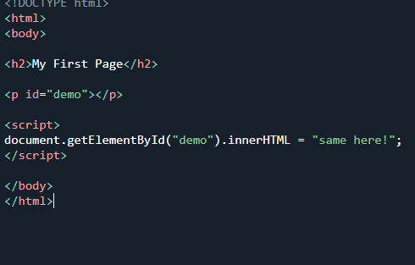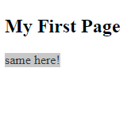

Get element id is a method while inner html is a property.

innerHtml = to get content initialized.

getElemntbyid = to access element that is defined with an id.

***Dom document:***

Is the owner of all objects defined in your webpage.

To access any element in html page (usually defined with id) this is done by first apply an object called document.

See below example :

To find html elements:

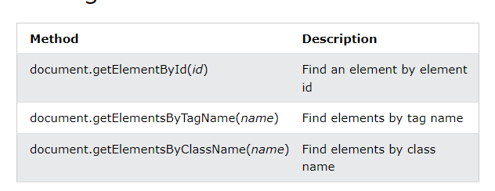

There are other ways as well to access an element by tagname or byclassname , **tag names** are like <p> </p> , <h1></h1> etc

**Classname** = #thisisclass.

To change html elements look (value)

Classname:

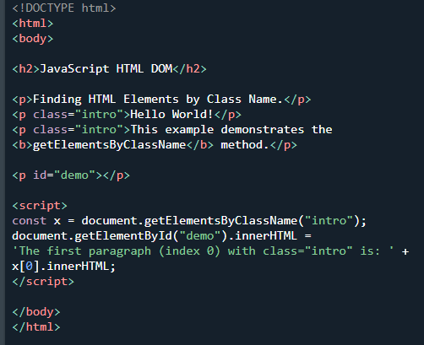

Tagname:

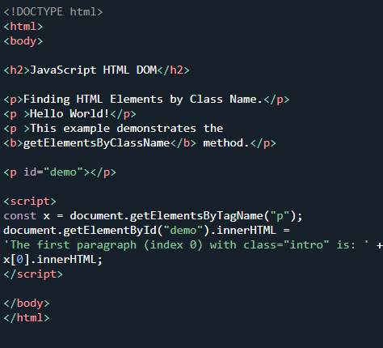

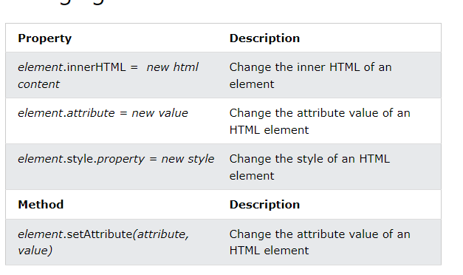

**Adding or deleting html elements**:

To add new elements in any tag here for instance adding elements into paragraph or in order or unordered list.

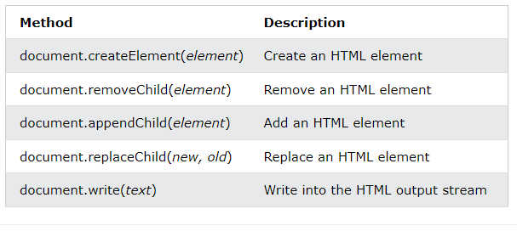

Adding even:

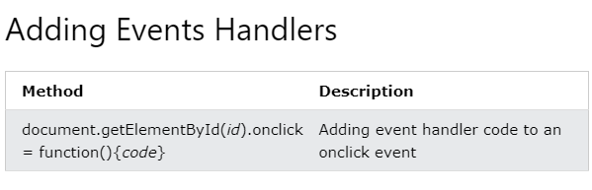

***Css Selector:***

To access specific paragraphs from multiple paras.

Called query selector we can use for that.

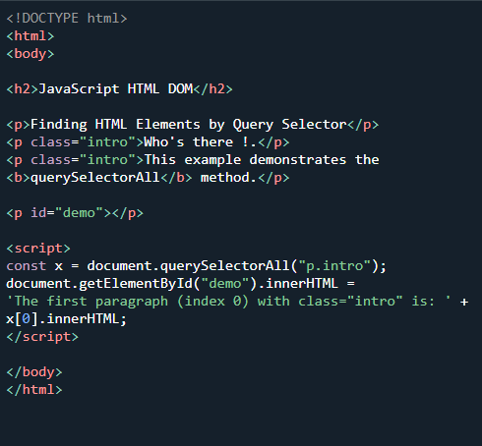

***Change HTML Content of existing value through script :***

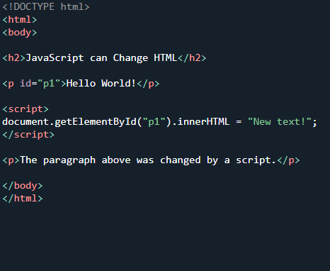

***Changing HTML attribute :***

To change pictures and other graphics apart from values.

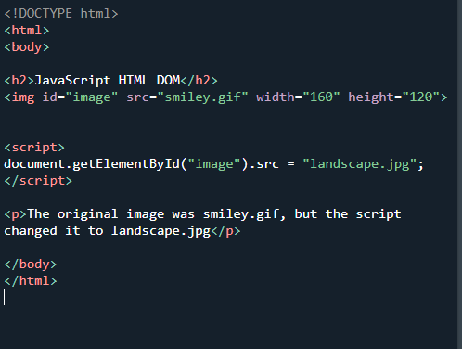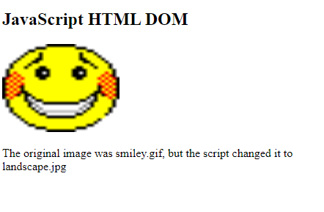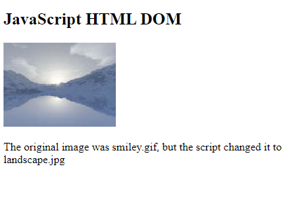

***Changing dynamic HTML attribute :***

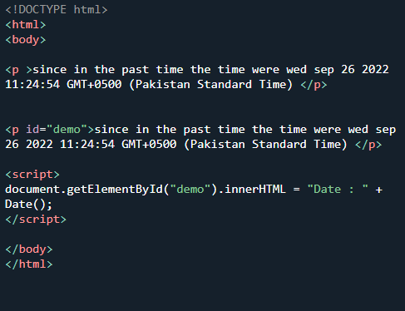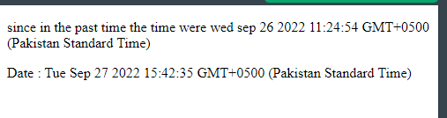

Instead of above we can also do this :

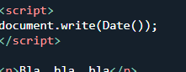

***JS FORMS :***

It is a form where we can input something and something as an output will return.

Here we use fields like number field , password field etc for input and declare it with their tags as well to access values input by user init.

